**Name:** Bophelo Thwala

**Student No.:** ST10446904

**Module:** MAST5112

**Lecturer:** Mr. Steven Ndaye

**Mobile App Scripting POE – part 2**

Table of Contents

The Restaurant App 2

INTRODUCTION AND ABOUT 3

FEATURES (Explained): 3

Git Hub Link: 8

Demonstration Video: 8

REFERENCES OF ASSETS 8

# The Restaurant App

HELLO!

WELCOME TO THE APPLICATION!

INTRODUCTION AND ABOUT

The restaurant app is an app where users can visually see the menu and order items through the app by going to the “Add Items” page to enter the dish name, description, course, and price and add the as they will display on them on the “Order” page.

## FEATURES (Explained):

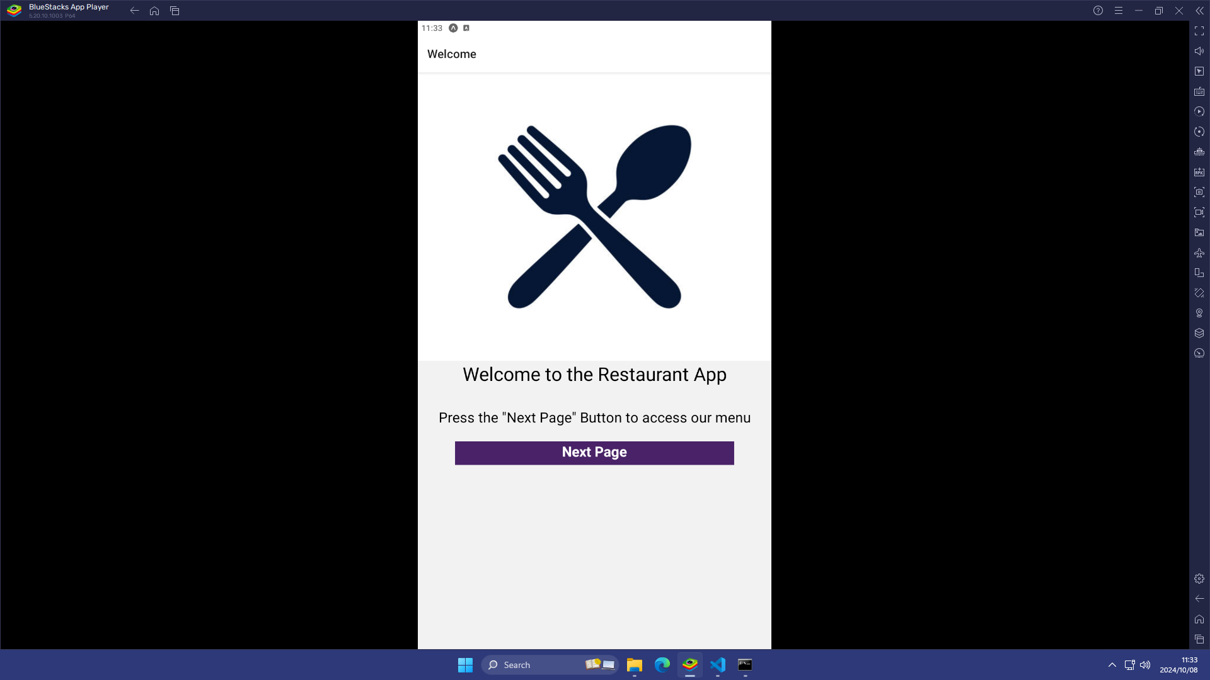

1. Welcome Page

The “Welcome” page has the restaurant logo, text and a button. A welcome text is displayed and an instruction text informing the user to click a button saying “Next Page” for them to access the other parts of the app.

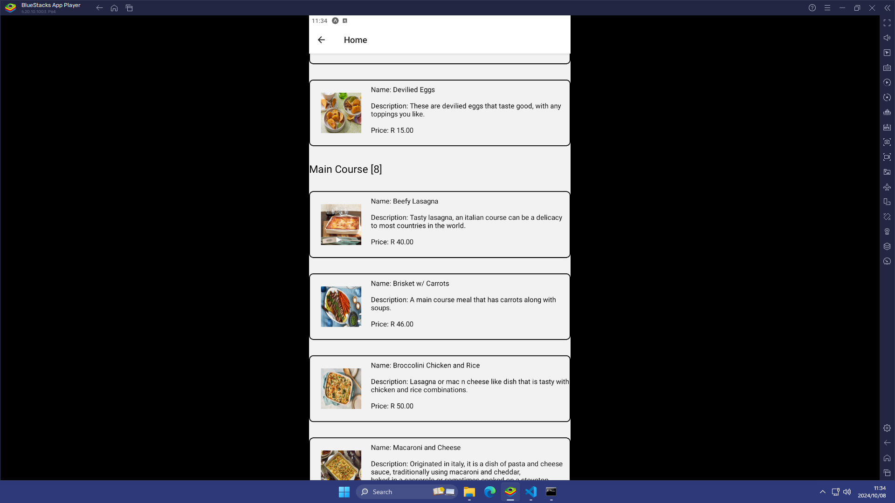

1. Home Page

The “Home” page displays a menu filtered by four courses (Appetizers, Main Course, Dessert, Beverages). The whole menu consists of six [6] appetizer meals, eight [8] main course meals, eight [8] kinds of desserts, and ten [10] beverages for the user to choose from ranging to the total of 32 food items in the menu. It is just a visual menu for the users to look at.

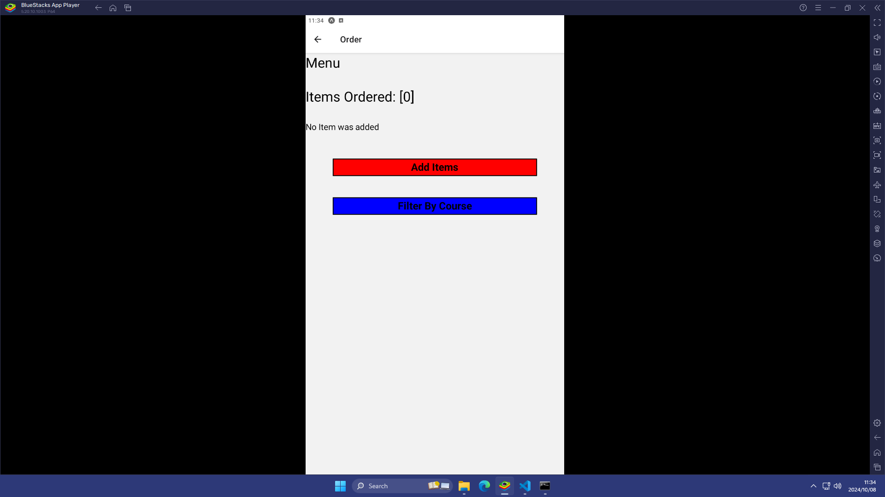

1. Order Page

The “Order” page consists of a display where the user can see the number of items ordered by “Items Ordered: [0]”, and the name, description, course type, price of the item they ordered. If no item was ordered the message will display: “No Item was added”.

Two buttons (Add Items: Will take you to the Add Items page where the user can add menu items and Filter by Course: The user can filter menu items according to the type of course).

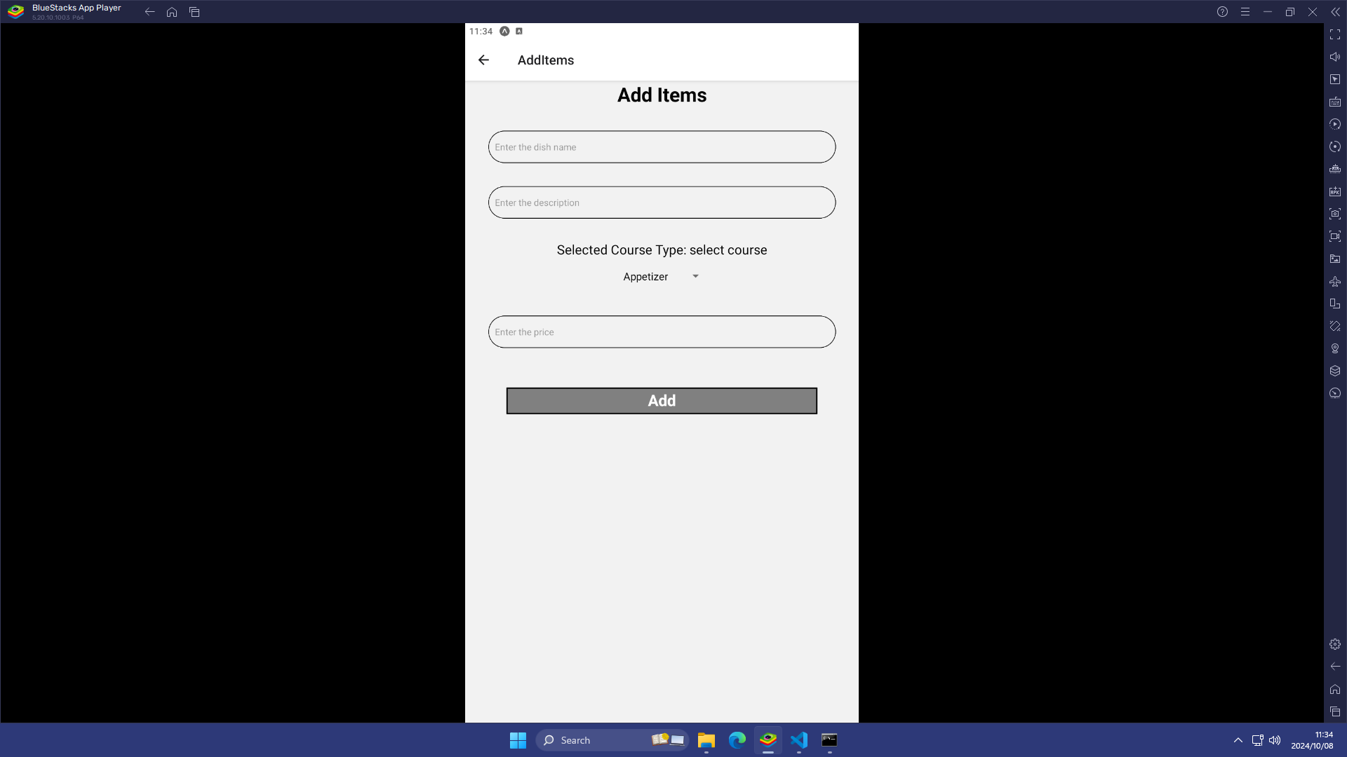

1. Add Items Page

The “Add Items” page will allow the user to enter the dish details they want. The user can enter the name of the dish, the description of the dish, the course for the dish and the price of the dish.

After entering the details of the dish, the user can enter the “Add” button to submit the order and it will display on the “Order” page and will take you back to the “Order” page for the user to see the item entered from the “Add items” page.

However, if all or one or more of the fields are empty and course type is not selected (e.g. description of the dish is empty but other fields are entered), the alert message will display: “Please fill in all the fields”. So, ensure you have entered all fields.

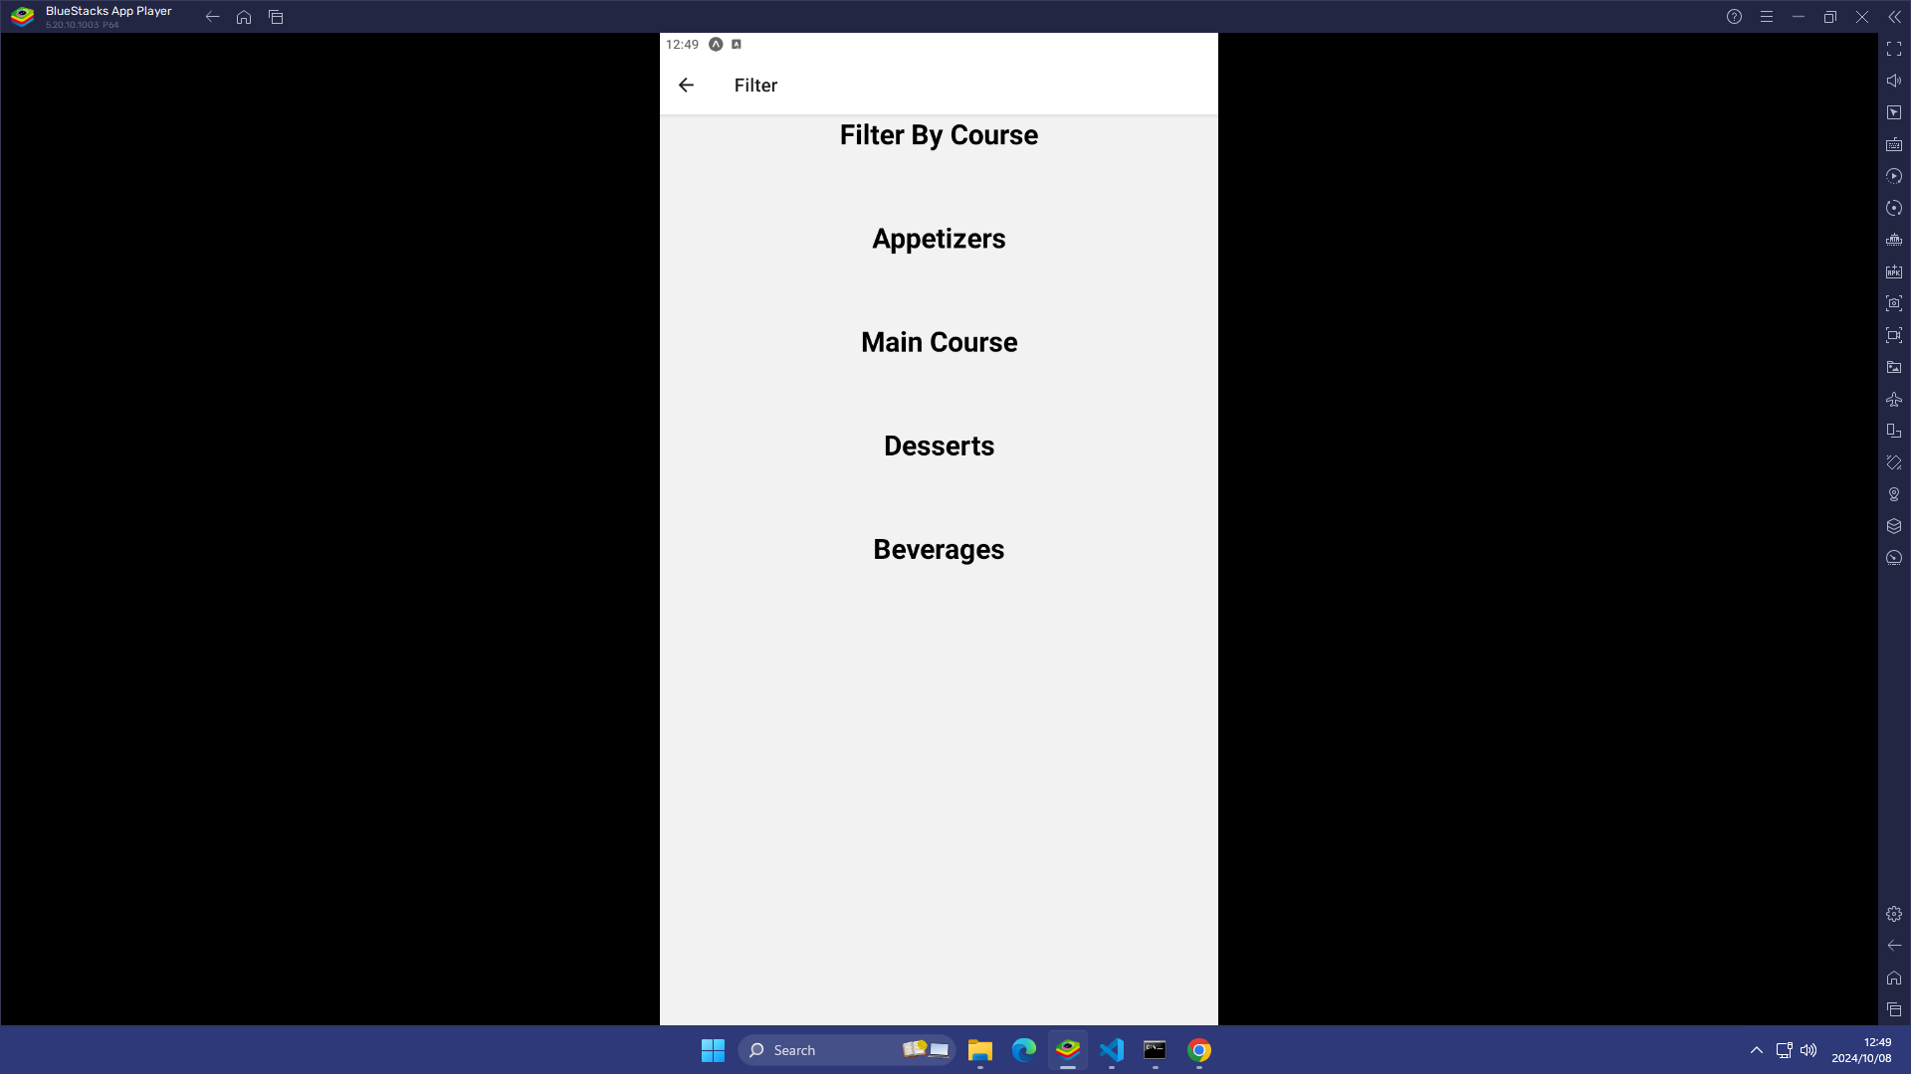

1. Filter Page (for POE part 3- final)

The “Filter” page shows the menu items filtered based on the course type.

(e.g. Beverages: Name: Water, Description: Just a glass of water can be also (spring or mineral) anyway you like it, Price: R 12.00).

Git Hub Link:

<https://github.com/IIEWFL/mast5112-part-2-Bophelo-G-THWALA.git>

## Demonstration Video:

<https://youtu.be/rqftAbTTj5w>

[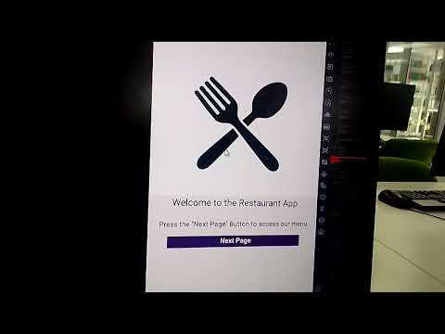](https://youtu.be/rqftAbTTj5w)

# REFERENCES OF ASSETS

Appetizers, Main Course and Dessert

Obtained from: Southern Living

Link: https://www.southernliving.com/food

Author: Southern Living

Beverages

Tea:

Obtained from: iStock

Link: <https://www.istockphoto.com/search/2/image-film?phrase=rooibos+tea>

Coffee:

Obtained from: Bones Coffee Company

Link: <https://www.bonescoffee.com/a/blog/sugar-cookie-coffee-latte-recipe>

Milkshakes:

Obtained from: getty images

Link: <https://www.gettyimages.com/detail/photo/strawberry-milkshake-royalty-free-image/157583034?adppopup=true>

Author: inhauscreative

Author Profile: <https://www.gettyimages.com/search/photographer?photographer=inhauscreative>

Cooldrinks:

Obtained from: iStock

Link: <https://www.istockphoto.com/photo/cola-glass-with-ice-cubes-gm530428650-93410511?searchscope=image%2Cfilm>

Author: gresei

Author Profile: <https://www.istockphoto.com/portfolio/gresei?mediatype=photography>